NAME:B.Tejaswini
REGNO.:192412684
ECA18– OPTOELECTRONICS AND OPTICAL COMMUNICATION
CO4 – INVESTIGATIVE ASSIGNMENT
Ultra-High-Speed Photonic Transport Link:
Technology Evaluation, Impairment Mitigation,
and Integrated System Design

Executive Summary
This report proposes a 32-channel DWDM transport system with a net target rate of 200 Gb/s per channel, giving an aggregate line capacity of 6.4 Tb/s before any additional framing or FEC overhead. The recommended design uses dual-polarization coherent 16-QAM (DP-16QAM), an integrated silicon-photonic Mach–Zehnder modulator (with a qualified thin-film lithium-niobate option where lower drive voltage or bandwidth margin is required), an AWG-based multiplexer/demultiplexer, hybrid distributed Raman plus EDFA amplification, and coherent-receiver DSP.
The design is a technically credible baseline rather than a claim of completed laboratory validation. The supplied brief does not specify span length, per-channel amplifier input/output powers, channel spacing value, fiber attenuation, target BER, or a measured OSNR budget. Therefore, calculations that depend on these values are explicitly parameterized or presented as clearly labelled design assumptions. A final deployment decision should follow OptiSystem/OptSim or MATLAB validation and hardware qualification.

Design at a Glance
Item | Proposed baseline
Channels / channel rate | 32 × 200 Gb/s
Aggregate capacity | 6.4 Tb/s (gross line rate, before overhead)
Modulation | DP-16QAM; 4 bits/symbol/polarization, 8 bits/symbol across two polarizations
Symbol rate | 25 GBd for 200 Gb/s gross payload-equivalent; increase if FEC/framing overhead must be included
Channel grid | 50 GHz nominal starting point; confirm exact grid and occupied spectrum against the selected interface/standard
Modulator | High-speed EO MZI in silicon photonics; thin-film LiNbO₃ alternative for extra linearity/drive margin
Amplification | Distributed Raman + EDFA, with gain-flattening and per-channel power equalization
Receiver | Dual-polarization coherent receiver, ADCs, CD equalizer, adaptive 2×2 MIMO equalizer, carrier recovery, FEC; optional DBP
Primary limitation | DP-16QAM has higher OSNR sensitivity than lower-order formats; power, nonlinearities and ASE must be budgeted together

1. Stage 1 – Interpret the Communication Requirement

1.1 Capacity and service baseline
The network contains 32 wavelength channels, each carrying 200 Gb/s. Aggregate gross line capacity is:
Ctotal = N × Rch = 32 × 200 Gb/s = 6,400 Gb/s = 6.4 Tb/s
The system should maintain acceptable pre-FEC BER and Q-factor with sufficient OSNR margin, while limiting insertion loss, nonlinear penalties, crosstalk, power consumption, and thermal drift. A deployment design must define the reach and fiber-span plan before an absolute OSNR or amplifier count can be finalized.

1.2 Key metrics and why they matter
Metric | Engineering meaning / verification
Aggregate capacity | 6.4 Tb/s gross across 32 channels; verify whether stated 200 Gb/s is client payload or line rate.
Spectral efficiency | Gross bit rate divided by occupied bandwidth. For DP-16QAM, ideal uncoded efficiency is 8 bit/s/Hz at Nyquist packing; practical efficiency is lower due to FEC and guard bands.
OSNR | Signal power relative to ASE noise in a specified reference bandwidth. Must exceed the chosen modulation/FEC threshold with margin.
BER / Q-factor | Pre-FEC BER predicts FEC operating margin. For Gaussian noise, Q and BER are related, but exact threshold depends on receiver and FEC.
Launch power | Too low worsens receiver/ASE-limited performance; too high increases SPM, XPM and FWM.
Modulator bandwidth / Vπ | Must support the electrical drive spectrum at the selected baud rate without excessive loss or distortion.
Insertion loss / thermal stability | Affects link budget and integrated-photonic reliability, especially for resonant rings and dense PICs.
Crosstalk / polarization | AWG/MMI leakage, PDL and PMD can degrade channel isolation and coherent equalization.

1.3 Impairment-to-mitigation mapping
Impairment | Physical cause | Main mitigation
Chromatic dispersion (CD) | Wavelength-dependent group delay in fiber | Coherent DSP frequency-domain or FIR CD equalization
Polarization-mode dispersion (PMD) | Random birefringence and differential group delay | Adaptive dual-polarization MIMO equalizer
SPM / XPM | Kerr nonlinearity from a channel's own intensity or neighboring channels | Launch-power optimization; Raman/EDFA design; optional DBP
FWM | Mixing among WDM frequencies in nonlinear fiber | Adequate grid planning, dispersion-aware fiber, controlled launch power
ASE noise | Spontaneous emission amplified by optical amplifiers | Low-noise amplification, fewer spans where practical, OSNR budgeting
AWG/MMI crosstalk | Finite isolation and imperfect fabrication | Component qualification, thermal control, channel filtering and power balance
PDL / reflections | Polarization-dependent component loss and back-reflections | Low-PDL components, isolators, careful connector/splice practices

1.4 Investigation requirement statement
Design a 32-channel DWDM link delivering 6.4 Tb/s gross capacity at 200 Gb/s per channel. The design should use a spectrally efficient modulation format, maintain OSNR above its selected pre-FEC threshold with an engineering margin, mitigate CD and PMD using coherent DSP, limit Kerr nonlinear penalties by optimizing launch power, and use flat-gain amplification across the occupied grid. The final design must report component assumptions, link budget, BER/Q-factor and OSNR evidence from simulation, plus thermal, footprint, reliability and standards-interface considerations.

2. Stage 2 – Modulation and Modulator Selection

2.1 Modulation format comparison
Format | Bits per symbol (per pol.) | Approx. baud for 200 Gb/s | Advantages | Limitations
NRZ-OOK | 1 | 200 GBd single-pol. | Simple transmitter/receiver; robust implementation | Very high baud rate and poor spectral efficiency for this target
PAM4 | 2 electrical intensity levels per symbol | 100 GBd for 200 Gb/s single lane | Two bits per symbol; mature intensity modulation ecosystem | Lower eye opening per level; demanding linearity and SNR; not polarization-multiplexed coherent QAM
DPSK / DQPSK | 1 / 2 | Depends on polarization and encoding | Differential detection can simplify phase recovery | Generally less flexible/effective than coherent high-order QAM for high spectral efficiency
16-QAM | 4 per polarization | 50 GBd for 200 Gb/s single-pol.; 25 GBd with DP | Good compromise between spectral efficiency and OSNR tolerance | Requires coherent receiver and phase recovery
DP-16QAM | 8 across two polarizations | 25 GBd for 200 Gb/s gross | High spectral efficiency at moderate baud rate | Higher OSNR requirement and DSP complexity than DP-QPSK
DP-64QAM | 12 across two polarizations | 16.67 GBd ideal for 200 Gb/s gross | Higher ideal spectral efficiency | More stringent OSNR/linearity; less reach margin

Baud-rate calculation: a dual-polarization 16-QAM symbol carries 4 bits on each polarization, or 8 bits per dual-polarization symbol interval. Thus Rs = 200 Gb/s ÷ 8 = 25 GBd, assuming the 200 Gb/s figure excludes no extra FEC/framing overhead. If 200 Gb/s is net client payload, the required line rate and baud rate must be raised to accommodate overhead.
For PAM4, the simple single-lane gross calculation is 200 Gb/s ÷ 2 = 100 GBd. A practical PAM4 system may use multiple electrical lanes and/or parallelization; this simplified comparison is not a complete interface mapping.

2.2 Channel spacing and spectral efficiency
A nominal 50 GHz grid is a reasonable starting design assumption for a 25-GBd DP-16QAM channel, provided the transmitter pulse shaping, spectral roll-off and implementation meet the chosen interface mask. The ideal Nyquist spectral efficiency is 200 Gb/s ÷ 25 GHz = 8 bit/s/Hz gross for DP-16QAM. With 50 GHz spacing, grid-based efficiency is 200/50 = 4 bit/s/Hz per channel slot. The difference reflects unused guard spectrum and the distinction between occupied bandwidth and grid spacing.
The exact channel plan must be selected from the applicable frequency-grid specification and interface agreement. ITU-T G.698 family recommendations cover optical interfaces for single-channel and multichannel applications; they do not imply that every 200-Gb/s coherent implementation automatically conforms to a particular application code.

2.3 Modulation mechanism and architecture
Mechanism / structure | Speed and implementation notes | Decision
Electro-optic (EO) | Fast field-driven index change; suitable for tens of GBd and beyond with engineered electrodes and traveling-wave design. | Select for data modulation.
Acousto-optic (AO) | Uses acoustic waves; often useful for switching/frequency shifting, but generally not the preferred mechanism for a compact 25-GBd data modulator. | Not selected for primary data modulation.
Thermo-optic | Thermal index change; typically slower and power-hungry, useful for tuning and configuration. | Use for slow phase/ring tuning only.
Magneto-optic | Magnetic-field-induced polarization rotation; useful for specialized nonreciprocal functions, not the main high-speed data modulator. | Not selected for symbol modulation.
Kerr effect | Intensity-dependent refractive index; important in fiber nonlinearities and useful in some nonlinear photonic functions. | Model as impairment; not selected as main modulator.
Silicon-photonic MZI | Broadband, comparatively tolerant of wavelength drift; footprint larger than a ring but integration is scalable. | Preferred baseline.
Micro-ring resonator | Very compact and potentially low energy, but resonant bandwidth, wavelength drift and thermal tuning are critical. | Use only where thermal control and tuning budget are acceptable.
Thin-film LiNbO₃ MZI | High bandwidth and good linearity; may offer drive-voltage/bandwidth advantages depending on device design, with packaging/material integration trade-offs. | Qualified alternative if silicon MZI misses link margin.
EO polymer | Potentially high EO response and low Vπ, but long-term stability, packaging and reliability qualification matter. | Future/alternative platform subject to reliability evidence.

Vπ and bandwidth are device-specific rather than fixed material constants. A report should quote values from the actual modulator datasheet or peer-reviewed device paper. For this design, the acceptance criterion is a measured electro-optic bandwidth comfortably above the Nyquist frequency of the chosen 25-GBd waveform, with sufficient margin for pulse shaping, driver response and implementation penalties. A numeric Vπ cannot be honestly fixed from the assignment brief alone.

2.4 Design Decision 1

I recommend DP-16QAM at 25 GBd with an EO Mach–Zehnder modulator because it reaches 200 Gb/s gross with lower baud rate and better grid efficiency than single-polarization PAM4/OOK alternatives. An integrated silicon-photonic MZI is the scalable baseline; thin-film LiNbO₃ should be substituted if device-level testing shows inadequate linearity, Vπ, or bandwidth margin.

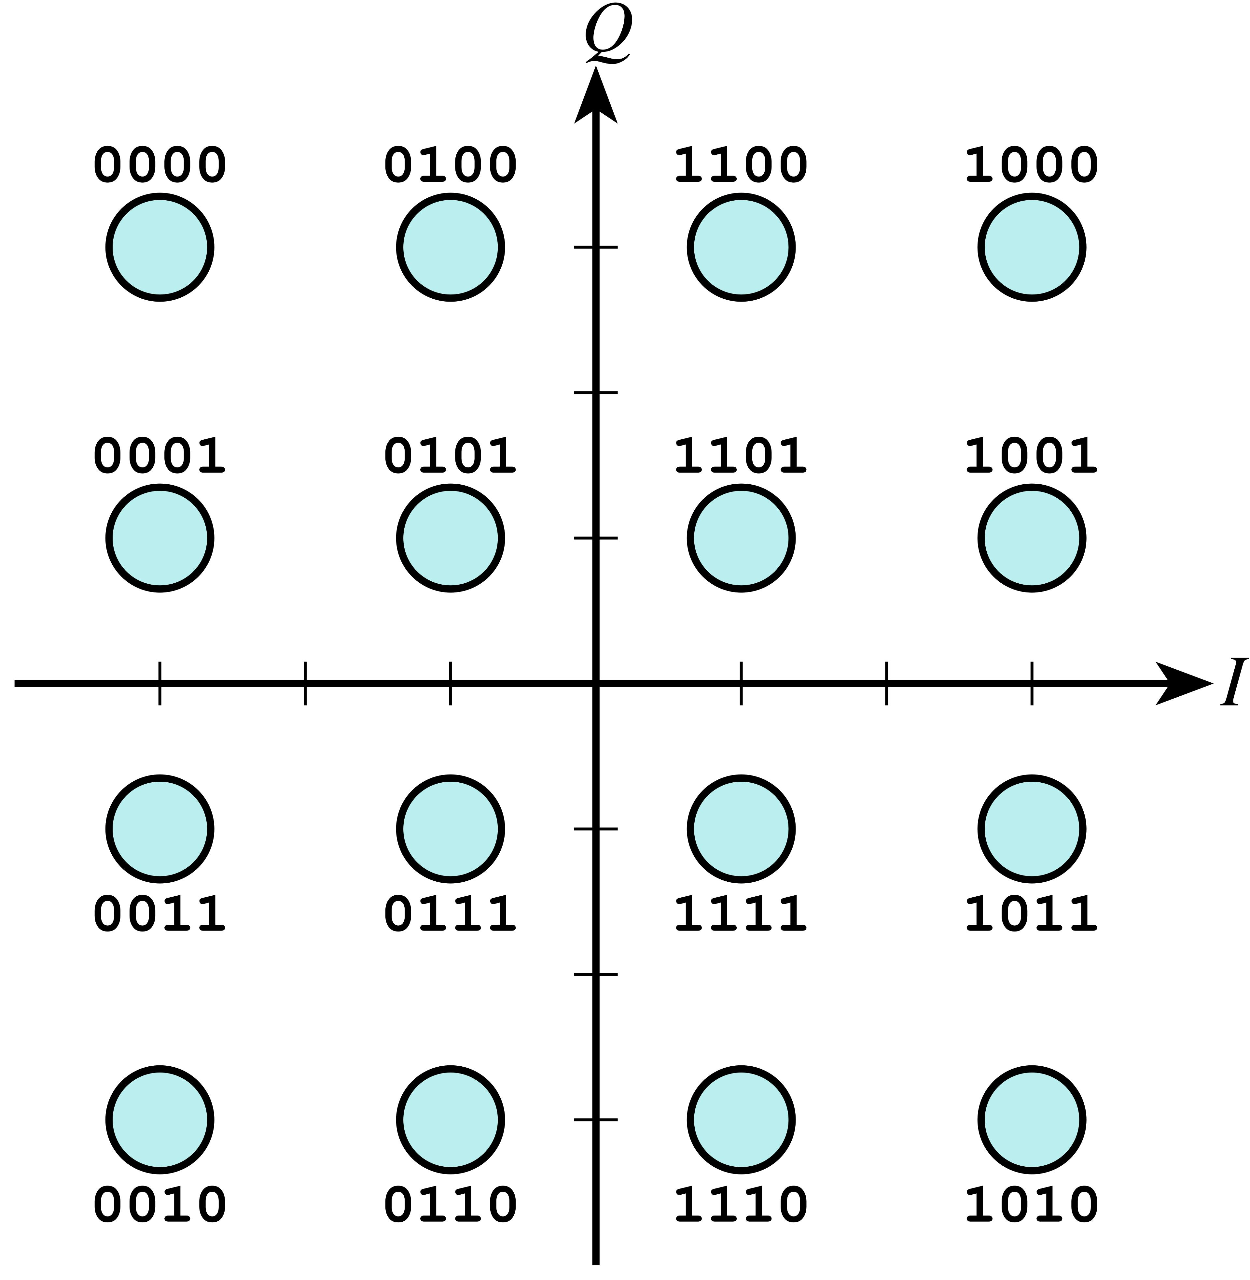

3. Stage 3 – Optical Amplification Configuration (20 Marks)

3.1 Amplifier comparison
Amplifier | Strengths | Limitations / use
EDFA | Mature C-band technology, high output power, practical multi-channel gain | ASE accumulates across spans; gain tilt and noise figure require management
SOA | Compact, electrically driven, potential PIC integration | Pattern effects, nonlinearities, polarization dependence and crosstalk can limit long-haul WDM use
Lumped Raman | Can tailor gain band and improve noise performance in suitable configurations | Pump complexity and safety/operational overhead
Distributed Raman | Gain occurs along transmission fiber, improving effective noise performance and OSNR | Pump design, double-Rayleigh scattering and operational complexity must be considered
Hybrid Raman + EDFA | Combines distributed gain with EDFA output power; can improve OSNR relative to EDFA-only design | Higher system complexity, pump control and safety requirements

3.2 Total amplifier output power
The assignment brief leaves the per-channel input and target output power values blank. Therefore, an exact numeric span gain cannot be derived from the provided data. The general calculation is:
Ptotal,out (dBm) = Pch,out (dBm) + 10 log10(32) = Pch,out + 15.05 dB
Ptotal,out (W) = 32 × 10^((Pch,out − 30)/10)
Span gain per channel is Gspan (dB) = Pch,out (dBm) − Pch,in (dBm), before accounting for connector, multiplexer, fiber, splice and other passive losses. The amplifier gain must cover the span loss plus the desired engineering margin, but the chosen output power must also stay below the nonlinear optimum.

3.3 Illustrative calculation (assumptions only)
For illustration only, assume −3 dBm per channel at the amplifier output and −10 dBm per channel at its input. These values are not supplied by the assignment and must be replaced by the final link budget.
Quantity | Calculation | Illustrative result
Total output power | −3 dBm + 10 log10(32) | 12.05 dBm
Total output power in watts | 10^((12.05−30)/10) | ≈ 0.016 W (16 mW)
Per-channel span gain | −3 − (−10) | 7 dB

The total output-power sum assumes all 32 channels have equal power. If gain, wavelength-dependent loss or loading varies by channel, calculate each channel separately and sum linear powers in watts, not dBm.

3.4 Gain flatness and ASE/OSNR
EDFA gain varies with wavelength. Over 32 channels, gain tilt causes some channels to be launched too high (increasing nonlinear penalties) and others too low (reducing OSNR). A gain-flattening filter (GFF), amplifier gain control and per-channel equalization should keep channel powers within the system tolerance. Raman gain can be tailored to reduce effective noise accumulation, while the EDFA provides practical output power.
Each amplifier adds ASE noise. As spans are cascaded, signal power is restored but noise also accumulates; the OSNR does not reset at each amplifier. A valid OSNR budget must state the reference bandwidth (commonly 0.1 nm in optical measurements), amplifier noise figure, gain, span count, channel power and filtering assumptions. Since these inputs are absent, no defensible absolute OSNR number is claimed here.

3.5 Design Decision 2
I recommend a hybrid distributed Raman + EDFA line-amplifier architecture with GFF and dynamic channel-power equalization because it can improve effective OSNR while maintaining sufficient C-band output power. The final choice is conditional on a span-by-span power/OSNR budget, Raman pump safety review, and confirmation that all 32 channels remain within output-power and gain-flatness limits.

4. Stage 4 – Impairment Compensation and Coherent DSP

4.1 Physical impairments
Effect | Impact on transmission | Mitigation
Chromatic dispersion | Spreads pulses; creates frequency-dependent phase and inter-symbol interference. | Digital CD equalization in coherent receiver; optical DCF only if a special system constraint justifies it.
PMD | Polarization components experience different delays; changes with temperature and mechanical stress. | Adaptive dual-polarization MIMO equalization; monitor PDL and differential group delay.
SPM | A channel's intensity changes its own phase through the Kerr effect. | Optimize launch power; use DSP/DBP when complexity and reach justify it.
XPM | Power fluctuations in neighboring WDM channels phase-modulate a channel. | Power balancing, channel plan and nonlinear-aware DSP.
FWM | Multiple optical frequencies mix and generate new frequencies; severity depends on dispersion, spacing and power. | Grid/dispersion planning and launch-power control.
ASE | Amplifiers add broadband spontaneous-emission noise. | Low-noise amplifier design, span/OSNR optimization and adequate FEC margin.
PDL | Component loss differs with polarization, disturbing the received signal. | Low-PDL components, careful optical design and adaptive receiver equalization.

4.2 Optical compensation versus DSP
Dispersion-compensating fiber can compensate accumulated CD optically but adds insertion loss, footprint and nonlinear interaction, and it is less flexible when operating across changing channel rates and formats. Optical phase conjugation can counter some propagation impairments in a carefully symmetric link, but needs additional optical hardware and is not a general replacement for coherent DSP. Coherent DSP is programmable, supports adaptive CD/PMD compensation and avoids much of the loss associated with DCF; it does not eliminate ASE noise and has limits for nonlinear compensation.

4.3 Recommended DSP sequence
- Coherent optical front end: polarization-diverse optical hybrid and balanced photodetectors convert signal phase/amplitude into electrical I/Q components.
- ADC and front-end correction: sampling, gain/offset correction and timing alignment.
- Resampling and chromatic-dispersion compensation: frequency-domain equalization or long FIR filters remove accumulated linear CD.
- Matched filtering and timing recovery: align symbol timing and reduce out-of-band noise.
- Adaptive 2×2 complex MIMO equalizer: separate the two polarizations and track PMD/rotation; CMA may initialize equalization, followed by decision-directed adaptation for QAM.
- Frequency-offset estimation and carrier-phase recovery: correct laser frequency difference and phase noise; use modulation-aware phase estimation for 16-QAM.
- Soft demapping and FEC: calculate bit likelihoods and decode to achieve the required post-FEC error performance.
- Optional digital backpropagation: use split-step Fourier propagation in reverse to partially compensate deterministic Kerr nonlinearities; apply only if simulation shows enough Q/BER improvement to justify computation and power.

4.4 DBP trade-off
Digital backpropagation numerically approximates the inverse of fiber propagation and can reduce deterministic SPM/XPM penalties. Its benefit depends on the number of steps per span, modeled bandwidth, polarization treatment and accuracy of the fiber parameters. Computational cost grows rapidly with bandwidth and step count, and DBP cannot undo ASE noise or all stochastic/nonlinear interactions. The baseline should therefore use CD equalization and adaptive MIMO as standard functions, then compare DBP on/off using identical launch-power sweeps.

4.5 Design Decision 3
I recommend coherent DSP with frequency-domain CD equalization, adaptive 2×2 MIMO polarization demultiplexing, carrier-frequency and phase recovery, soft-decision FEC, and optional DBP. This sequence addresses linear dispersion and polarization effects efficiently; DBP is included only when simulation proves a worthwhile improvement in pre-FEC BER/Q-factor at acceptable power and latency.

5. Stage 5 – Integrated WDM Transmission Strategy (15 Marks)

5.1 Block-level architecture
32 coherent transmitters (tunable lasers + DP-16QAM EO MZIs)
↓
Channel monitoring / per-channel power control
↓
AWG or MMI-based DWDM multiplexer + isolator
↓
SMF-28 spans ← distributed Raman pump(s) + EDFA + GFF
↓
Pre-amplifier / channel equalization / AWG demultiplexer
↓
Dual-polarization coherent receiver (optical hybrid + balanced PDs)
↓
ADC → timing/resampling → CD equalizer → 2×2 MIMO → carrier recovery
↓
Soft demapper → FEC decoder → 200-Gb/s client interface
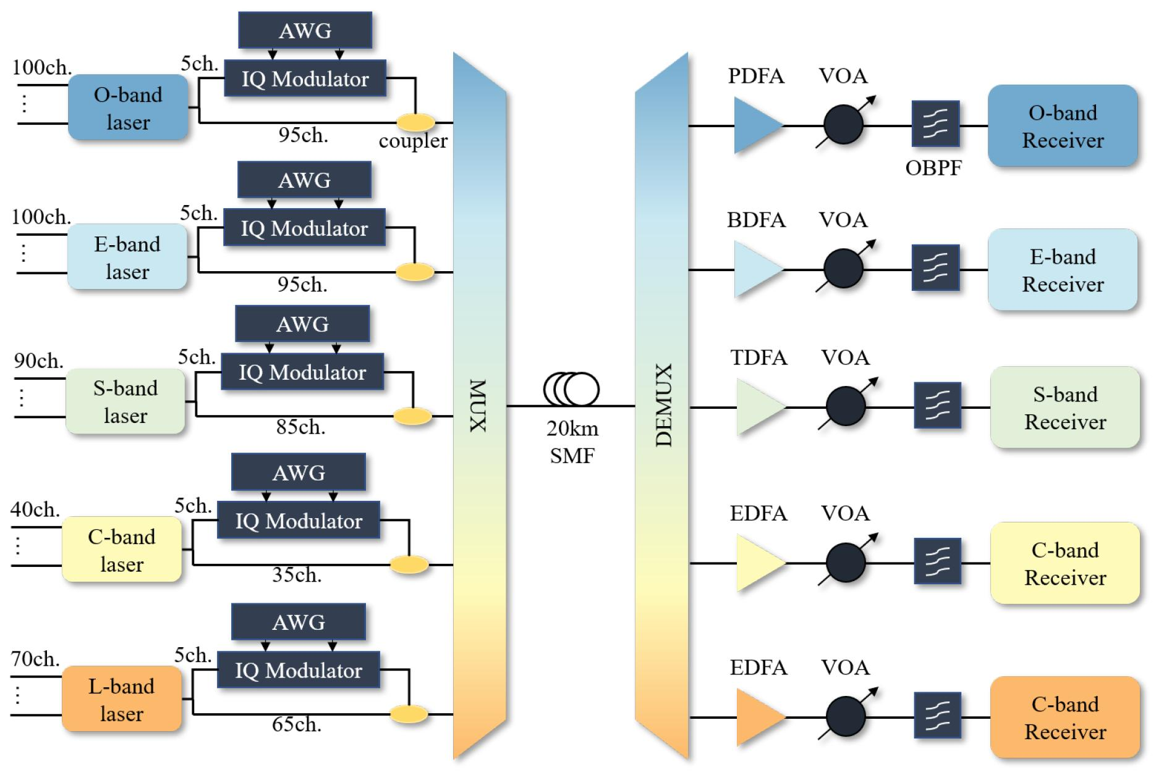

5.2 System parameter table
Parameter | Proposed value / status
Number of wavelengths | 32
Per-channel gross line rate | 200 Gb/s
Aggregate gross line capacity | 6.4 Tb/s
Modulation | DP-16QAM
Symbol rate | 25 GBd, assuming 200 Gb/s gross and no additional overhead
Grid spacing | 50 GHz assumed for planning; verify selected frequency grid and spectral mask
Wavelength range | C-band is the proposed operating band; exact carrier frequencies are assigned on the chosen grid
Laser linewidth | Specify from selected coherent transceiver; verify via carrier-phase-noise simulation
Fiber | SMF-28 class single-mode fiber; use actual datasheet attenuation, dispersion and nonlinear coefficient
Amplifier | Distributed Raman + EDFA; NF, gain and output power to be entered from selected equipment
Modulator | EO MZI; enter measured bandwidth, Vπ and insertion loss from chosen part
DSP | CD frequency-domain equalizer, adaptive 2×2 MIMO, carrier recovery, soft-decision FEC; optional DBP
FEC target | Select a specific code and its pre-FEC threshold; brief does not state a numeric BER threshold

5.3 Cross-stage trade-offs
- DP-16QAM reduces baud rate for a given bit rate, improving spectral efficiency, but requires better OSNR and more precise phase recovery than lower-order formats.
- Hybrid Raman–EDFA amplification can improve OSNR, but adds pumps, controls, cost and operational complexity.
- AWG/MMI insertion loss consumes link budget. If additional launch power is used to compensate, Kerr nonlinear penalties can increase; prefer lower-loss components and equalization before increasing power.
- A ring resonator can reduce footprint but requires wavelength and temperature control. An MZI is a more forgiving baseline for broadband high-speed modulation.
- DSP improves tolerance to CD and PMD, but receiver compute, memory, power and latency scale with baud rate, channel count and algorithm complexity.

5.4 Standards and compliance note
The design should be checked against the exact applicable edition and application code of ITU-T G.698 and the relevant IEEE 802.3 and OIF-CEI interface specifications. These documents have different scopes: optical transport interface recommendations, Ethernet physical-layer definitions and electrical/optical interface agreements are not interchangeable. Compliance cannot be asserted from architecture alone; verify optical power, wavelength/frequency, spectral mask, transmitter quality, receiver sensitivity, BER/FEC and interoperability against the selected profile.

5.5 Design Decision 4
I recommend the integrated 32-channel DP-16QAM DWDM architecture as the preferred candidate for simulation and qualification because it combines 6.4-Tb/s gross capacity, high spectral efficiency, scalable photonic integration and adaptive coherent DSP. Deployment should be conditional—not automatic—on measured OSNR margin, BER/Q-factor, gain flatness, nonlinear launch-power optimum, thermal stability and standards-profile verification.

6. Stage 6 – Verification and Critical Evaluation
Requirement | Target / criterion | Current design evidence / status
Aggregate WDM capacity | 6.4 Tb/s = 32 × 200 Gb/s | Calculated: 6.4 Tb/s gross
Modulation / spectral efficiency | DP-16QAM; 25 GBd at 200 Gb/s gross | Analytical: 8 bit/symbol across two polarizations; 8 bit/s/Hz ideal Nyquist efficiency
Grid / channel occupancy | Selected grid compatible with occupied spectrum | 50 GHz is a planning assumption; confirm pulse shaping, roll-off and interface mask
Modulator bandwidth / footprint | Bandwidth above signal requirement; stable PIC operation | Architecture selected; exact bandwidth, Vπ and loss require device data
Amplifier output / gain | Enough gain for span loss and required output power | Formula supplied; exact numeric result awaits missing per-channel input/output powers
Gain flatness | All channels within system tolerance | GFF + dynamic channel power equalization proposed; verify with amplifier profile
OSNR / BER | OSNR above selected DP-16QAM/FEC threshold with margin | Not numerically verified; requires NF, gain, span count, channel power and FEC threshold
CD / PMD mitigation | Residual impairment within receiver DSP capability | CD frequency-domain equalizer + adaptive 2×2 MIMO selected
Nonlinear tolerance | Operate near Q/BER-optimal launch power | Launch-power sweep and DBP on/off comparison required
Standards / interoperability | Exact selected profiles passed | Architecture-level intent only; formal conformance testing remains

6.1 Simulation plan
Build the model in OptiSystem/OptSim or MATLAB with 32 WDM sources, DP-16QAM transmitters, MZI modulators, AWG multiplexer, SMF spans, Raman/EDFA amplifiers, AWG demultiplexer and coherent receivers. Sweep channel launch power and span count. Record optical spectrum, OSNR by channel, received constellation, pre-FEC BER/Q-factor, and Q-factor versus launch power. Compare EDFA-only with Raman–EDFA, compare CD-only DSP with CD+MIMO, and evaluate DBP enabled versus disabled. Use consistent random seeds, filter bandwidths, FEC threshold and receiver settings across comparisons.
- Minimum plots: optical spectrum after multiplexer and final span; DP-16QAM constellation before/after DSP; pre-FEC BER or Q-factor versus launch power; OSNR across all 32 channels.
- Record all model inputs: fiber length/attenuation/dispersion/nonlinear coefficient, amplifier NF/gain, per-channel launch power, grid, laser linewidth, modulator bandwidth/Vπ, receiver noise and DSP parameters.
- Do not present simulated or illustrative plots as measured hardware results. Label assumptions and distinguish model outputs from specifications.

6.2 Final engineering decision
DECISION: YES, WITH CONDITIONS — adopt the proposed architecture as the design candidate for detailed simulation and prototype qualification, not as a deployment-ready system yet. The strongest evidence is the capacity calculation (6.4 Tb/s) and DP-16QAM baud-rate calculation (25 GBd under the stated gross-rate assumption). Hybrid Raman–EDFA and coherent DSP are technically appropriate options for controlling ASE, CD, PMD and some nonlinear penalties. However, absolute OSNR, BER/Q-factor, reach, power consumption and standards compliance cannot be verified from the assignment brief because the required span, amplifier, component and FEC parameters are not specified. Deployment approval should be granted only after the verification table is completed with simulation and equipment data.

7. Conclusion
The recommended system is a 32-channel, 6.4-Tb/s gross DWDM link using 25-GBd DP-16QAM, EO MZI transmitters, AWG/MMI multiplexing, hybrid Raman–EDFA amplification with gain flattening, and coherent receiver DSP. This is a balanced design choice: DP-16QAM provides high spectral efficiency without the OSNR penalty of 64-QAM, while coherent DSP addresses CD and PMD and can partially mitigate nonlinear effects. The engineering recommendation remains conditional on a complete link budget, actual device specifications, OSNR/BER simulation, launch-power optimization, and formal interface conformance checks.

References
- ITU-T, Recommendation G.698 series, Multichannel optical interfaces for single-channel and multichannel applications (consult the applicable current edition and application code).
- IEEE Std 802.3, Ethernet, including the applicable 802.3ct / 802.3ck clauses for the selected physical-layer interface; verify the precise clause and edition before claiming compliance.
- Optical Internetworking Forum (OIF), Common Electrical I/O (CEI) Implementation Agreements; use the agreement applicable to the selected electrical interface and baud rate.
- G. P. Agrawal, Fiber-Optic Communication Systems, 4th ed., Wiley, 2010.
- G. P. Agrawal, Nonlinear Fiber Optics, 6th ed., Academic Press, 2019.
- E. Ip and J. M. Kahn, “Compensation of dispersion and nonlinear impairments using digital backpropagation,” Journal of Lightwave Technology, vol. 26, no. 20, pp. 3416–3425, 2008.
- R. Essiambre et al., “Capacity limits of optical fiber networks,” Journal of Lightwave Technology, vol. 28, no. 4, pp. 662–701, 2010.
- Vendor datasheets for the chosen coherent transceiver, EO modulator, AWG, EDFA and Raman amplifier should be added to the final submission, with revisiones and measured values.

